**Minia University faculty of**

**Computers and Information**



**Ventilation and Energy Control System (VECS)**

**A graduation project submitted to:** Information System Department

Faculty of Computers and Information - Mania University

In Partial Fulfillment of the Requirements for the Degree of

Bachelor of Computer Science

**By:**

|  |  |  |  |  |
| --- | --- | --- | --- | --- |
| Name | E-mail |  | Name | E-mail |
| Adel Abid | [adelabid@gmail.com](mailto:adelabid@gmail.com) |  | Keroles Ibrahim | [keroles.i@gmail.com](mailto:keroles.i@gmail.com) |
| Amgaad Ezzat | [amgaad.e@gmail.com](mailto:amgaad.e@gmail.com) |  | Ragaa Maher | ragaa.m@gmail.com |
| John Latif Shokr | [johanlatiff@gmail.com](mailto:johanlatiff@gmail.com) |  | Milad Ezzat Fahmy | milad.e.fahmy@gmail.com |

**Under Supervision of:**

|  |  |
| --- | --- |
| **Prof. Moheb Ramzy Girgis**  Computer Science Department  Faculty of Science  Minia University  E-mail: moheb.geirgis@mu.edu.eg | **TA. Mina Samman Younan**  Computer Science Department  Faculty of Computers and Information  Minia University  E-mail:  [mina.younan@mu.edu.eg](mailto:%20mina.younan@mu.edu.eg) |

**- 2017 –**

# Abstract

Industrial countries face lots of problems with air pollution and use of energy. This has effects on human health negatively. for example, in factories, manufacturing process produces gases that are harmful to humans and products, such as carbon dioxide, nitrogen and other harmful gases. Surrounding environment is an important factor in the production process, such as temperature and humidity. On the other hand, saving consumed energy is recommended in any factory this can be achieved by devices and machines.

Factories are trying hard to get rid of the negative effects of manufacturing process and reducing energy consumption as much as possible. In order to get rid of carbon dioxide, manual methods of air purification are used.  For energy conservation, the responsible officer must search for machines that consume a lot of energy and try to control them manually, or shutdown machines that work without need manually.

Our proposed project will be able to identify causes and sources of harmful gases that produced from   manufacturing process. also, the temperature, air pressure and humidity.

The proposed system can monitor and control machines. It can analyses all information gathered about machine electricity consumption to take smart action about turning on/off these machines, which in the same time enhance performance of the production process. We will choose specific factory to implement this project on it.

# Table of Contents

Abstract 2

Table of Contents 3

List of Figures 5

1. **Introduction** 6

1.1 Field 6

1.2 The Manufacturing Process of sugar: 6

1.2.1 Preparation and processing 6

1.2.2 Juice extraction pressing 7

1.2.3 Purification of juice — clarification and evaporation 7

1.2.4 Crystallization 8

1.2.5 Centrifuging 8

1.2.6 Drying and packaging 9

1.3 Problems 9

1.3.1 Air pollution 9

1.3.2 Energy consumption 10

1.4 Current Solution 11

1.5 Summery 11

2. **Background** 12

2.1 Motivating Scenario 12

2.2 Hardware 12

2.2.1 Arduino [2] 12

2.3 Software 14

2.3.1 Desktop application 14

2.3.2 Mobile Application 14

2.3.3 Web Application 15

We use angularjs, bootstrap, html, jQuery as front-end, and we use nodejs as back-end. 15

Node js ? 15

2.4 Summery 16

**3** **Project Initiation** 17

3.1 Introduction 17

3.2 System request 17

3.3 Feasibility study 18

3.4 Development Tools 20

3.4.1 Hardware 20

3.4.2 Software 20

3.5 Risk Management 20

3.6 Work plan 22

3.7 Summery 23

**4** **System Architecture** 24

4.1 Introduction 24

4.2 System Architecture 25

4.3 Actors and Use-cases 27

A. Use Cases and Actors 27

B. Use Cases 27

C. Use Case Diagram 32

4.4 System Sequence Diagram (SSD) 32

4.5 Candidate Conceptual classes 34

4.6 Domain Model 35

4.7 Contracts 35

4.8 Collaboration Diagram 38

4.9 Design Class Diagram 41

4.10 Designs 42

4.10.1 Desktop application 42

4.10.2 Mobile Application 44

4.10.3 Web Application 45

**5** **. System Implementation** 46

5.1 Introduction 46

5.2 First section: desktop APP:- 46

5.3 Second section: Website APP:- 48

5.4 Third section: Mobile APP:- 52

References 55

# List of Figures

Figure ‎1‑1 The Manufacturing Process of sugar 9

Figure ‎2‑1 Arduino Uno Board 14

Figure ‎2‑2 Arduino sample code 14

Figure ‎2‑3 C# sample code 15

Figure ‎4‑1 System Architecture 26

**Chapter 01**

# Introduction

This chapter is organized as follows: Sections 1 presents an introduction to the field of sugar industry in Egypt followed by steps of manufacturing process of sugar and its effect it on the environment and energy consumption.

## Field

The sugar industry is one of the most important industries in Egypt, because sugar is used by citizens in the various food sectors and enters into the manufacture of many other food, where production is about 2.2 million tons per year and is dependent in the sugar industry on two main crops, sugar cane and beets. Where the area of ​​sugar cane cultivated about 275 thousand acres and the area of ​​beet about 200 thousand acres

The sugar industry in Egypt depends on 8 factories and is divided into 3 factories in Qena (Nagaa Hammadi, Deshna, Qous), 2 in Aswan (Edfu, Komoombo), Gerga factory in Sohag, Arment factory in Luxor.   
Due to increased consumption in sugar and increased production of sugar. This is due to increased production of harmful gases and increased pollution of the environment and also increased energy consumption

## The Manufacturing Process of sugar:

### Preparation and processing

After the cane arrives at the mill yards, it is mechanically unloaded and excessive soil and rocks are removed. The cane is cleaned by flooding the carrier with warm water (in the case of sparse rock and trash clutter) or by spreading the cane on agitating conveyors that pass through strong jets of water and combing drums (to remove larger amounts of rocks, trash, and leaves, etc.). At this point, the cane is clean and ready to be milled.

When the beets are delivered at the refinery, they are first washed and then cut into strips. Next, they are put into diffusion cells with water at about 175 degrees Fahrenheit (79.4 degrees Celsius) and sprayed with hot water counter currently to remove the sucrose.

### Juice extraction pressing

Two or three heavily grooved crusher rollers break the cane and extract a large part of the juice, or swing-hammer type shredders (1,200 RPM) shred the cane without extracting the juice. Revolving knives cutting the stalks into chips are supplementary to the crushers. (In most countries, the shredder precedes the crusher.) A combination of two, or even all three, methods may be used. The pressing process involves crushing the stalks between the heavy and grooved metal rollers to separate the fiber (bagasse) from the juice that contains the sugar.

As the cane is crushed, hot water (or a combination of hot water and recovered impure juice) is sprayed onto the crushed cane counter currently as it leaves each mill for diluting. The extracted juice, called verso, contains 95 percent or more of the sucrose present. The mass is then diffused, a process that involves finely cutting or shredding the stalks. Next, the sugar is separated from the cut stalks by dissolving it in hot water or hot juice.

### Purification of juice — clarification and evaporation

The juice from the mills, a dark green color, is acid and turbid. The clarification (or [defecation](http://www.madehow.com/knowledge/Defecation.html)) process is designed to remove both soluble and insoluble impurities (such as sand, soil, and ground rock) that have not been removed by preliminary screening. The process employs lime and heat as the clarifying agents. Milk of lime (about one pound per ton of cane) neutralizes the natural acidity of the juice, forming insoluble lime salts. Heating the lime juice to boiling coagulates the albumin and some of the fats, waxes, and gums, and the precipitate formed entraps suspended solids as well as the minute particles.

To concentrate this clarified juice, about two-thirds of the water is removed through vacuum evaporation. Generally, four vacuum-boiling cells or bodies are arranged in series so that each succeeding body has a higher vacuum (and therefore boils at a lower temperature). The vapors from one body can thus boil the juice in the next one—the steam introduced into the first cell does what is called multiple-effect evaporation. The vapor from the last cell goes to a condenser. The syrup leaves the last body continuously with about 65 percent solids and 35 percent water.

### Crystallization

[Crystallization](http://www.madehow.com/knowledge/Crystallization.html) is the next step in the manufacture of sugar. Crystallization takes place in a single-stage vacuum pan. The syrup is [evaporated](http://www.madehow.com/knowledge/Evaporation.html) until saturated with sugar. As soon as the saturation point has been exceeded, small grains of sugar are added to the pan, or "strike." These small grains, called seed, serve as nuclei for the formation of sugar crystals. (Seed grain is formed by adding 56 ounces [1,600 grams] of white sugar into the bowl of a slurry machine and mixing with 3.3 parts of a liquid mixture: 70 percent methylated spirit and 30 percent glycerin. The machine runs at 200 RPM for 15 hours.) Additional syrup is added to the strike and evaporated so that the original crystals that were formed are allowed to grow in size.

The growth of the crystals continues until the pan is full. When sucrose concentration reaches the desired level, the dense mixture of syrup and sugar crystals, called massecuite, is discharged into large containers known as crystallizers. Crystallization continues in the crystallizers as the massecuite is slowly stirred and cooled.

### Centrifuging

The high-speed centrifugal action used to separate the massecuite into raw sugar crystals and molasses is done in revolving machines called centrifugal. A centrifugal machine has a cylindrical basket suspended on a spindle, with perforated sides lined with wire cloth, inside which are metal sheets containing 400 to 600 perforations per square inch. The basket revolves at speeds from 1,000 to 1,800 RPM. The raw sugar is retained in the centrifuge basket because the perforated lining retains the sugar crystals. The mother liquor, or molasses, passes through the lining (due to the centrifugal force exerted). The final molasses (blackstrap molasses) containing sucrose, reducing sugars, organic no sugars, ash, and water, is sent to large storage tanks.

### Drying and packaging

Damp sugar crystals are dried by being tumbled through heated air in a granulator. The dry sugar crystals are then sorted by size through vibrating screens and placed into storage bins. Sugar is then sent to be packed in the familiar packaging we see in grocery stores, in bulk packaging, or in liquid form for industrial use.

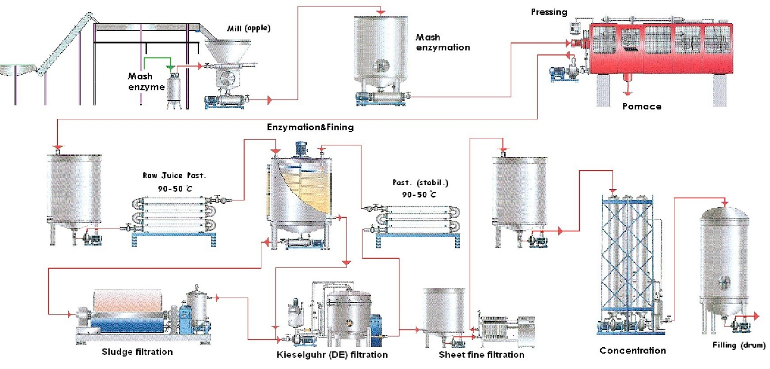

Figure ‎1‑1 The Manufacturing Process of sugar

## Problems

The sugar industry produces a lot of problems and wastes that harm the environment and human health and also affect all living organisms and even affect the planet in general and from these problems**:**

### Air pollution

**The Manufacturing Process of sugar** cause of many problems, damages to environment and human health also and most of the sugar mills use bagasse as a fuel in boilers and produce electricity energy. The burning of bagasse in boilers produces particulate matter, oxides of nitrogen, carbon, Sulphur and water vapour. Some of problems:

* Extraction process cause of producing humidity and dust.
* Evaporation stage cause of decreasing in temperature and troubles in the pressure as a result of heating, CO2 and GUYER (which cause of losing sight and chest allergy).
* Boiling also cause of increasing in temperature, pressure and humidity of the around area.
* In packaging stage, sugar can be infected, if it exposure to high temperature or humidity.
* Also there are some of gases are produced within this process [1]:
  + 1. NO2 (common one that cause of air pollution).
    2. CO (called the silent killer because of danger within usage).

### Energy consumption

The process of manufacturing sugar goes through multiple stages and each phase consumes a lot of energy.

At the stage of preparation and processing, sugar cane is transferred to a functioning electrical circuit. This function is operated manually and ignites all the time until it becomes empty. This starts up energy and we need boiling water at 79 ° C. The process of gluten continues all the time even without The need for more boiling and also in the remaining stages

Energy sources in the factories can be electricity, natural gas, solar energy, or petroleum energy. There is big problem with energy usage, hug with energy usage, huge quantities can be wasted because of misuse machines be turned on although it is not used. Air conditioning devices still on although we don't need them ,as the temperature is convenient for workers and products, that is another one of wasting energy. So we use our system(VCES) for controlling in hole space in factory to organize the energy usage inside, Device(system) can turn on/off any machine or device inside the factory automatically to save energy from wasting.

## Current Solution

We search about a solution for these problems ,but we didn’t find except some of outer filters .

we propose a new idea which solves these problems s,The proposed solution has the following features:

* Dust
  + By using filters and central vacuum cleaner
* Light
  + If it up normal then turn off light or make it low
* Temperature
  + Manual open windows
* Humidity
  + Open ventilation sources such windows
* NO2
  + No Current Solution
* CO & CO2
  + By Ventilation manual
* Benz in Fire
  + Stop machine and cut power off manual
* Energy consumption
  + If a device is turned on without the employee turn off by hand

## Summery

In this chapter we discussed the field that we choose for implement the project, we discussed:

1. The steps of manufacturing of sugar.
2. the problem of pollution that produced from manufacturing of sugar.
3. the energy consumption
4. the current solution the solve these problems.

**Chapter 02**

# Background

## **Motivating Scenario**

The main objective of this chapter is to gain the required practical knowledge and skills for building simple physical testbeds for the VCES, which integrates the real world into the digital world into the digital world. Concrete steps for building a VCES testbed are presented.

Scope of this chapter, discusses evaluation of an integrated VCES testbed. This chapter focuses on the interaction between microcontrollers, sensors, actuators, and PCs using HTTP and ZigBee or Bluetooth protocols. The required platforms and devices for running examples in this chapter are follows:

* Platforms: C#, android, web technology and Arduino programming language.
* Devices: Examples in this chapter are for VECS application and will use the components in the following section.

## Hardware

### Arduino [2]

is the simplest of microcontrollers, whereby its hardware and software components are open-sourced. Arduino programming language is based on c++ programming language in Arduino IDE. Arduino is considered as tiny computer that can be programmed to perform a task [3].

|  |  |
| --- | --- |
| Figure ‎2‑1 Arduino Uno Board | Figure ‎2‑2 Arduino sample code |

Example code in Figure 2-2:

This example show how can read the humidity and temperature by using serial port. Int chk = DHT.read11(DHT11_PIN)

#include <dht.h> // calling the dht header in the program

dht DHT; // declare object from dht

#define DHT11_PIN 3 // define constant called DHT11_PIN with value 3

void setup () {

//put your setup code in this function, to run once, this is the initial values

Serial.begin(9600) // opens serial port and set data rate to 9600 bit/second

} // end setup () function

void loop () {

//put main code in this function, to run repeatedly

char inChar; //declare variable called inChar from type character

if (serial.available () > 0) { //check if the port is available

inChar = Serail.read(); // if serial is available read char from serial port

}

int chk = DHT.read11(DHT11_PIN) // declare variable called int chk and assign

// to it the constant DHT11_PIN

if (inChar == '1){ //if inChar that user enter it execute the following

Serial.println(" Humidity "); // print Humidity

Serial.println(DHT.humidity,1) // read humidity from environment

// and print the value

Serial.println(" Temperature "); // print Temperature

Serial.println(DHT.temperature,1) // read temperature from environment

}// end loop () function

}

## Software

### Desktop application

An application that runs stand-alone in a desktop or laptop computer. Contrast with "Web-based application," which requires the Web browser to run. The term may be used to contrast desktop applications with mobile applications that run in smartphones and tablets. In Windows, a desktop application is one that runs in the traditional Windows desktop in contrast to a tablet application that runs full screen. You can use c# for building computer desktop application. [4] [5]

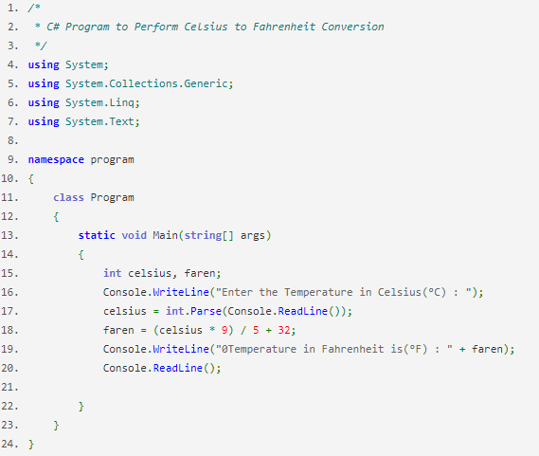

Figure ‎2‑3 C# sample code

* + 1. Mobile Application

Android is a [mobile operating system](https://en.wikipedia.org/wiki/Mobile_operating_system) developed by [Google](https://en.wikipedia.org/wiki/Google), based on a modified version of the [Linux kernel](https://en.wikipedia.org/wiki/Linux_kernel) and other [open source](https://en.wikipedia.org/wiki/Open_source) software and designed primarily for [touchscreen](https://en.wikipedia.org/wiki/Touchscreen) mobile devices such as [smartphones](https://en.wikipedia.org/wiki/Smartphone) and [tablets](https://en.wikipedia.org/wiki/Tablet_computer). In addition, Google has further developed [Android TV](https://en.wikipedia.org/wiki/Android_TV) for televisions, [Android Auto](https://en.wikipedia.org/wiki/Android_Auto) for cars, and [Android Wear](https://en.wikipedia.org/wiki/Android_Wear) for wrist watches, each with a specialized user interface. Variants of Android are also used on [game consoles](https://en.wikipedia.org/wiki/Video_game_console), [digital cameras](https://en.wikipedia.org/wiki/Digital_camera), [PCs](https://en.wikipedia.org/wiki/Personal_computer) and other electronics.

For using Seek Bar:

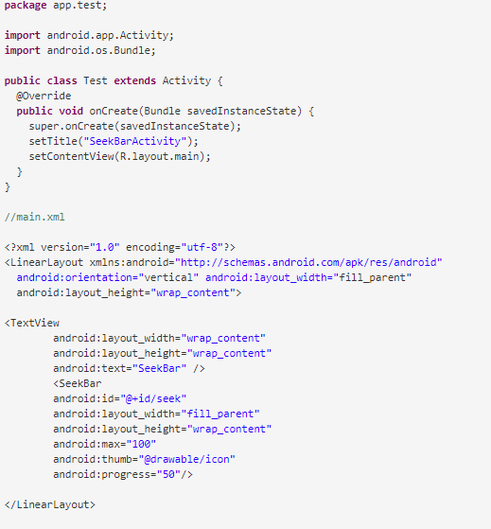

* + 1. Web Application

We use angularjs, bootstrap, html, jQuery as front-end, and we use nodejs as back-end.

Node js ?

Node.js is an open source server framework

Node.js is free

Node.js runs on various platforms (Windows, Linux, Unix, Mac OS X, etc.)

Node.js uses JavaScript on the server

Sample code of nodejs:

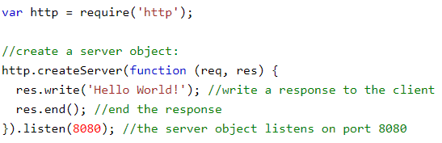

## Summery

In this chapter we discussed:

1. The hardware we will used in the project (Arduino)
2. The software we will use in the project

* C# for desktop application
* Android for mobile application
* Nodejs for web application

**Chapter 03**

# **Project Initiation**

## Introduction

In this section we discuss the scope of our proposed system (VECS), and the technical feasibility then we will discuss familiarity with application, familiarity with technical and the project size, followed by the economic feasibility which determines the total cost, total benefits, operational cost and development cost. Finally, we will discuss the organization feasibility of the project where the project champion and users of the project.

## System request

* project sponsor**:**

Prof. Moheb Girges Ramzy

* Business need

This project has been initiated to

1. Improve factories ventilation.
2. Alarm workers if there is any problem with air pollution.
3. Help managers control machines in the factory.
4. Improve quality of the factory product.

* Business requirements:

Our proposed project will be able to identify causes and sources of harmful gases that are produced during the   manufacturing process, e.g., the temperature, air pressure and humidity, then alarm workers by a notification from mobile app informs them that there is a problem.

Enable mangers to control machines (e.g., turning on/off).

* Business value:

1. Tangible benefits

* Improve and increase rate of factory production.

1. Intangible benefits

* Improve factories ventilation.
* Alarm workers if exist any problem with air pollution or changed in temperature.
* Help managers control machines in the factory.
* Special issues or constraints:
  1. Most of all sensors are not available.
  2. Can’t collect the correct information about factory.
  3. Clients and managers in the factory may not be familiar with these technologies and services (i.e., Users face problems in using the project).
  4. controlling machines is a complicated task.

## Feasibility study

* **Technical feasibility**
* Familiarity with application

Help the factory to improve its product and protect the workers from harmful gases.

* Familiarity with technology

We will use Arduino, web (html, CSS, java script, JQuery ) and android (java, xml ).

* Project size

Our team consists of six persons and we can finished our project in one year.

* **Economic feasibility**
* Total Benefits
* Total coast:
  + Operational Coast
* **Hardware costs: as we need to represent each room with a single Arduino and as mentioned earlier in the features section we need the following list of microcontrollers, sensors and actuators.**

1. Dell Power Edge T630TowerServer (XeonE5-2640V3/32/3 x2TB) 0.993 $.
2. TP-Link TD-W890In 150mbps
3. Wireless N ADSL2 modern Router 15.5 $.
4. PC 588.2 $.
5. 7 Arduino 61.7 $.
6. LM_35 sensor 0.882 $.
7. DHT_11 sensor 2.29 $.
8. GP2Y10 sensor 8.82 $.
9. MQ_135 sensor 38.2 $.
10. CdS sensor 0.588 $.
    * Development coast

* Programing costs.
* Maintenance costs.
* Testing costs.
* Tools costs.
* Organization Feasibility:
* Project champion:

The sponsor for our project is Pro. Moheb Gergis Ramzy.

* Users:

The users of this system are the factories of sugar.

## Development Tools

The system will be documented following structure of the software engineering (UML) and system analysis and design. Programming and Database tools are as follow:

### Hardware

* Arduino
* Sensors
* LM_35 sensor
* DHT_11 sensor
* GP2Y10 sensor
* MQ_135 sensor
* CdS sensor

### Software

* Desktop app (C#, SQL server ….) for controlling system.
* Web app (html, Css, JavaScript, nodeJs, expressJs, angularJs ….)
* Android app (java programming, XML) for receiving notifications and control machines.

## Risk Management

In this section we will discuss the risk management that may occur in the project, and if it happened the project may not complete, such as we have a little experience in programming and designs, and this problem is very difficult.

So, we will discuss how can avoid these risks and their likelihood.

**We face three risks management:**

The familiarity with application, project size and the time of the project. And the solution of each them.

|  |  |  |  |
| --- | --- | --- | --- |
| **Risk** | **Details** | **Likelihood of risks** | **How to avoid** |
| Risk #1  Familiarity with the application | The project team has not the enough experience about the nature of the work in our system, and learning this take a large time. | Low probability of risk. | We distributed the system tasks about every one of us and  theteam should study hard and save more time for self-study |
| Risk #2  Project size | The required features to make a complete application need much more time than available. So, the development of this system will be slow. | Moderate probability of risk. | Focus on primary functionality  then Lower functionality, if necessary. |

## Work plan

|  |
| --- |
|  |

## Summery

In this chapter we discussed all the required information to the system achieve the objectives and functions, and we understood more about our system.

* From this chapter we understood
* What is the business need?
* What is the business required?
* What is the business value?
* And what is constraints that may we face it?

And in this chapter, we are discussed the proposed features that we will use in the project, also we are discussed what is the risks management of the project? and in this chapter, we are discussed the work plan, in the work plan we are distributed all works to the team and every work has a particular duration to start and finished.

**Chapter 04**

# **System Architecture**

## Introduction

This chapter is organized as follows: Sections 1 presents an introduction about the whole chapter. Section 2 presents system architecture. Section 3 presents’ actors and use cases. Section 4 presents conceptual classes. Section 5 presents domain model. Section 6 presents contracts. Section 7 presents design mode, finally section 8 include the summary.

In this chapter we would discuss the architecture of our system in which we try to specify the positions of the microcontrollers, then extract the actors and its use cases to clarify system requirements followed by the conceptual classes, and primal design which explain the method of connecting sensors together

## System Architecture

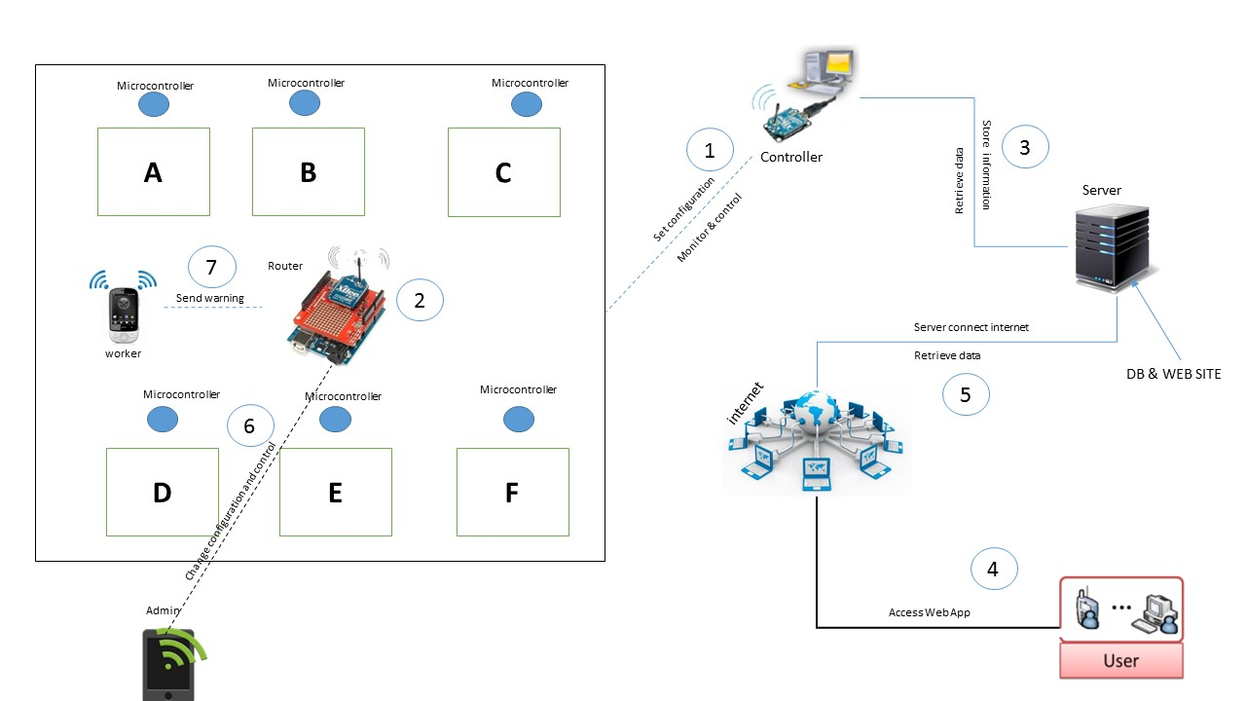

Figure ‎4‑1 System Architecture

**Figure 4-1** Part A represents the place that contain the machines of preparation and processing, part B represents the place that contain the machines of juice extraction pressing, part C represents the place that contains the machines of Purification of juice, part D represents the place the contain the machines of crystallization, part E represents the place that contain the machines of centrifuging and the part F represents the place that contain the machines of drying and packaging of sugar.

Such as in Figure **4-1** system architecture contains: controller (1), end point (2), microcontrollers, server, web App and mobile App. Part A, part B, part C, part D, part E, part F contain microcontroller connected with end point and some sensors such in table.

|  |  |
| --- | --- |
| Part A | * DHT_11(humidity and temperature detect) * QM_35(gases detected such as co2 etc.) * GP2Y10 (Dust sensor detect) * CdS Photoresistor (light detect) |
| Part B | * DHT_11(humidity and temperature detect) * QM_35(gases detected such as co2 etc.) |
| Part C | * DHT_11(humidity and temperature detect) * QM_35(gases detected such as co2 etc.) |
| Part D |  |
| Part E |  |
| Part F | * DHT_11(humidity and temperature detect) * QM_35(gases detected such as co2 etc.) |

Table 4‑1 sensors used in system

Controller is an Arduino with ZigBee connected with pc that contain desktop application, desktop app is intelligence app will be able to control the system and make decision dependence to the analysis information that it gathered from sensors, the controller connected with end point (Arduino with ZigBee) via wireless by ZigBee, all microcontroller in parts A, B, C, D, E and F connect with end point. The end point will be collecting data from sensors via microcontroller that connected with end point, and it send data to controller, and the controller take the data and process and analysis it and store information in server, controller make decisions dependence on the processed data and it send these decisions to end point, end point implement the decisions on specific devices.

User will be able to connect with the system by to ways, first way direct access when user is in the local network of system, all machines in the system take IP, Second way, indirect access via internet.

## Actors and Use-cases

### Use Cases and Actors

|  |  |
| --- | --- |
| **Actors** | **Goals** |
| Admin | * Register * Login * Control system |
| LM_35 sensor | * Detect the temperature |
| DHT_11 sensor | * Detect humidity and temperature |
| MQ_135 sensor | * Detect gases (NH3, NOx, ALCOHOL, BENZEN, SMOKE, CO2, Fire, etc.) |
| GP2Y10 sensor | * Detect Dust |
| CdS sensor | * Detect light |

### Use Cases

#### Use case Register

|  |  |  |  |  |
| --- | --- | --- | --- | --- |
| **Use Case Name:** Register | | | **ID:** UC-1 | **Priority:** High |
| **Actor:** Admin | | | | |
| **Description:** This use case describes, how admin register in VECS | | | | |
| **Trigger:** the system setup on specific factory and admin needs to control the system | | | | |
| **Type:** | * External | * Temporal | | |
| **Preconditions:**   1. Set up system on specific factory. 2. the system register is available within desktop application | | | | |
| **Main Success Senior:**   1. Admin open desktop app 2. System display the registration form 3. Admin enters full form (e.g. name, email, username, password, etc.) | | | | |
| **Postconditions:**   1. Admin's account added to the system 2. System required login | | | | |
| **Exceptions:**   1. if not first time, the admin starts the system    1. the system displays login form | | | | |

#### Use case login

|  |  |  |  |  |
| --- | --- | --- | --- | --- |
| **Use Case Name:** Login | | | **ID:** UC-2 | **Priority:** High |
| **Actor:** Admin | | | | |
| **Description:** This use case describes, how admin login to the system | | | | |
| **Trigger:** Admin needs to login to the system | | | | |
| **Type:** | * External | * Temporal | | |
| **Preconditions:**   1. One of the following apps available (desktop app, mobile app or website) 2. Admin have a permeation for login to the system | | | | |
| **Main Success Senior:**   1. Admin opens one of the apps 2. Open login form 3. System displays the form login 4. Admin enters username 5. Admin enters password 6. Admin submits login form 7. System verifies the form information 8. System validates the login information 9. System displays control panel to the admin | | | | |
| **Postconditions:** none | | | | |
| **Exceptions:**  7. if system finds:   1. missing username, it will prompt step 4 to admin, and it displays message " please enter the username" 2. missing password, it will prompt step 5 to admin, and it displays message "please enter the password"   8. if system fail to validates:   1. username, it will display message " incorrect username please try again", and will prompt admin to username field. 2. Password, it will display message "incorrect password please try again", and it prompts admin to the password field. | | | | |

#### Use case device control

|  |  |  |  |  |
| --- | --- | --- | --- | --- |
| **Use Case Name:** Device control | | | **ID:** UC-3 | **Priority:** High |
| **Actor:** Admin | | | | |
| **Description:** This use case describes, how admin will be able to control the system | | | | |
| **Trigger:** Admin needs to control system or some devices | | | | |
| **Type:** | * External | * Temporal | | |
| **Preconditions:**   1. Admin login 2. System display the control panel to the admin | | | | |
| **Main Success Senior:**   1. Admin choose the specific device, he needs control it 2. System display controller of this device. 3. Admin choose turn on / off the device or acquire information from the device 4. System implement the choosing of the admin on the device 5. System display done the action and status of the device | | | | |
| **Postconditions:** changing the status of the devices | | | | |
| **Exceptions:** none | | | | |

#### Use case detect temperature

|  |  |  |  |  |
| --- | --- | --- | --- | --- |
| **Use Case Name:** Detect temperature | | | **ID:** UC-4 | **Priority:** High |
| **Actor:** LM_35 sensor | | | | |
| **Description:** This use case describes, how the system handles the temperature sends by sensor | | | | |
| **Trigger:** LM_35 reads the temperature value in surround environment | | | | |
| **Type:** | * External | * Temporal | | |
| **Preconditions:**   1. System active | | | | |
| **Main Success Senior:**   1. LM_35 reads temperature and send it to the system 2. System gets the normal value from database 3. System compares the temperature with the normal value 4. If temperature's value is normal, system displays message "Temperature value is normal" | | | | |
| **Postconditions:** changing the status of the devices | | | | |
| **Exceptions:**  3.if the temperature is not normal:   1. System stores the value of abnormal temperature value with the date and time 2. System turns on the specific device to adjust the temperature. | | | | |

#### Use Case detect humidity

|  |  |  |  |  |
| --- | --- | --- | --- | --- |
| **Use Case Name:** Detect humidity | | | **ID:** UC-5 | **Priority:** High |
| **Actor:** DHT_11 sensor | | | | |
| **Description:** This use case describes, how the system handles the humidity values sent from the sensor | | | | |
| **Trigger:** DHT_11 reads the humidity value in surround environment | | | | |
| **Type:** | * External | * Temporal | | |
| **Preconditions:**   1. System active | | | | |
| **Main Success Senior:**   1. DHT_11 reads humidity and sends it to the system 2. System gets the normal value from database 3. System compares the humidity value with the normal value 4. If humidity's value is normal, system display message "Humidity value is normal" | | | | |
| **Postconditions:** changing the status of the devices | | | | |
| **Exceptions:**  3.if the humidity is not normal:   1. System stores the abnormal value humidity with the date and time in the database 2. System turns on the specific device to adjust the humidity. | | | | |

#### Use Case detect gases

|  |  |  |  |  |
| --- | --- | --- | --- | --- |
| **Use Case Name:** Detect gases | | | **ID:** UC-6 | **Priority:** High |
| **Actor:** MQ_135 sensor | | | | |
| **Description:** This use case describes, how the system handles the gases values sent from the sensor | | | | |
| **Trigger:** MQ_135 reads the gases value in surround environment | | | | |
| **Type:** | * External | * Temporal | | |
| **Preconditions:**   1. System active | | | | |
| **Main Success Senior:**   1. MQ_135 measures gases value and sends them to the system 2. System gets the normal values from database 3. System compares the gases values with the normal values 4. If gases' values are normal, system displays message "gases values is normal" | | | | |
| **Postconditions:** changing the status of the devices | | | | |
| **Exceptions:**  3.if the gases values are not normal:   1. System stores the abnormal value of the gases with the date and time in database 2. System turns on the specific device to adjust the gases. | | | | |

#### Use Case detect dust

|  |  |  |  |  |
| --- | --- | --- | --- | --- |
| **Use Case Name:** Detect Dust | | | **ID:** UC-7 | **Priority:** High |
| **Actor:** GP2Y10 sensor | | | | |
| **Description:** This use case describes, how the system handles the dust values sent from the sensor | | | | |
| **Trigger:** GP2Y10 sensor reads the dust value in surround environment | | | | |
| **Type:** | * External | * Temporal | | |
| **Preconditions:**   1. System active | | | | |
| **Main Success Senior:**   1. GP2Y10 measures dust value and sends them to the system 2. System gets the normal values from database 3. System compares the dust value with the normal value 4. If dust's value is normal, system display message "Dust values is normal" | | | | |
| **Postconditions:** changing the status of the devices | | | | |
| **Exceptions:**  3.if the dust value is not normal:   1. System stores the abnormal value of the dust with the date and time in database 2. System turns on the specific device to adjust the dust. | | | | |

#### Use Case detect light

|  |  |  |  |  |
| --- | --- | --- | --- | --- |
| **Use Case Name:** Detect light | | | **ID:** UC-8 | **Priority:** High |
| **Actor:** CdS sensor | | | | |
| **Description:** This use case describes, how the system handles the light value sent from the sensor | | | | |
| **Trigger:** CdS sensor reads the light value in surround environment | | | | |
| **Type:** | * External | * Temporal | | |
| **Preconditions:**   1. System active | | | | |
| **Main Success Senior:**   1. Cds measures light value and sends them to the system 2. System gets the normal values from database 3. System compares the light value with the normal value 4. If light is normal, system displays message "Light values is normal" | | | | |
| **Postconditions:** changing on the status of the devices | | | | |
| **Exceptions:**  3.if the light value is not normal:   1. System stores the abnormal value of the light with the date and time in database 2. System turns on the specific device to adjust the dust. | | | | |

### Use Case Diagram

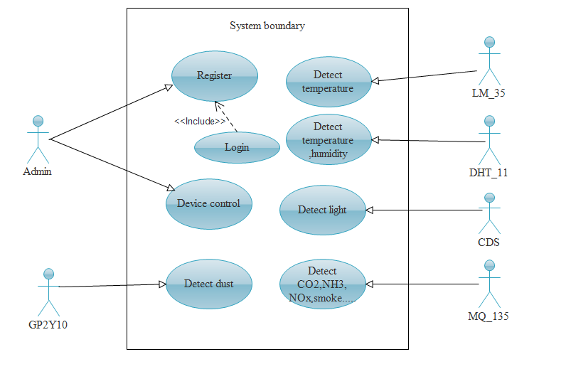

## System Sequence Diagram (SSD)

|  |
| --- |
|  |
|  |
|  |
|  |

## Candidate Conceptual classes

|  |  |  |
| --- | --- | --- |
| Conceptual class name | Included in your system or not??? | Why ?? |
| Admin | Included |  |
| Factory | Not | Out of the boundary |
| System | Not | The system itself |
| Normal values | Included |  |
| CDS sensor | Not include | This will become object |
| GP2Y10 sensor | Not include | This will become object |
| DHT_11 sensor | Not include | This will become object |
| LM_35 sensor | Not include | This will become object |
| MQ_135 sensor | Not include | This will become object |
| Environment | Not | Out of the boundary |
| Time | Not | Maybe an attribute |
| Date | Not | Maybe an attribute |
| Readings | Included |  |
| Network | Not | Out of the boundary |
| Sensors | Included |  |
| Devices | Included |  |
| Password | Not | Maybe an attribute |
| Username | Not | Maybe an attribute |
| Registration | Not | Maybe a function |
| Desktop APP | Not | Out of the boundary |
| Controller | Included |  |

## Domain Model

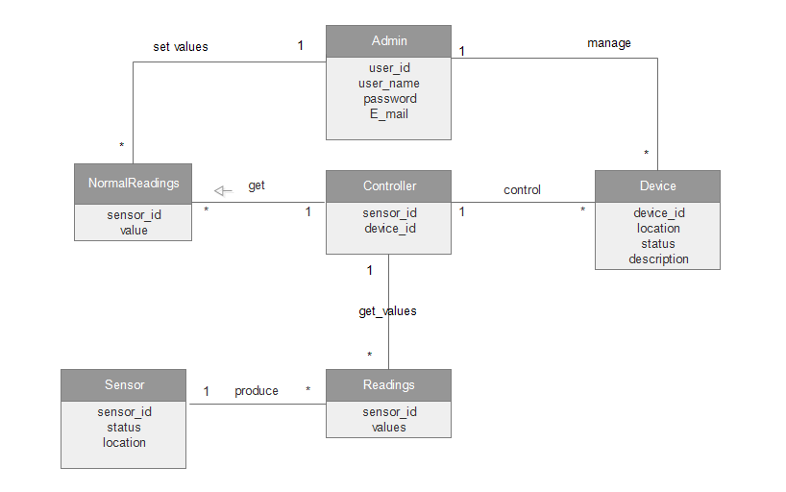

## Contracts

|  |  |
| --- | --- |
| CO1 | Contract Name: getReadings |
| getReadings (sensor _id: string,value:float) | Operation |
| Use Cases: detect temperature, detect humidity, detect lighting, detect gases, detect dust | Cross Reference |
| System must be active | Preconditions |
| * A readings object (R) was created * R was associated with controller * R.sensorId was set to id * R.value was set to value * R was associated with Device object | Postconditions |

|  |  |
| --- | --- |
| CO2 | Contract Name: getdeviceDetails |
| getdeviceDetails(device_id: ,string,status:bool,location:string  ,functionality:string,name:string) | Operation |
| Use Cases: Device control | Cross Reference |
| Current device control active | Preconditions |
| * A device object (D) was created * D was associated with Admin * D.device_Id was set to id * D.Status set to status | Postconditions |

|  |  |
| --- | --- |
| CO3 | Contract Name: manageDevice |
| managedevice(device_id: string, status: Boolean) | Operation |
| Use Cases: device control | Cross Reference |
| device control must be active | Preconditions |
| * A device object (D) was modified * D.deviceId was set to id * D.status was set to status * D was associated with Admin | Postconditions |

|  |  |
| --- | --- |
| CO4 | Contract Name: automanageDevice |
| automanage (device_id: string, status: Boolean) | Operation |
| Use Cases: Device Control | Cross Reference |
| device control must be active | Preconditions |
| * A controller object (C) was modified * C.sensorId was set to id * C.sensorStatus set to value * C was associated with Device | Postconditions |

|  |  |
| --- | --- |
| CO5 | Contract Name: compare |
| compare (l curentVvalue :NormalReadings,  curentVvalue:Readings) | Operation |
| Use Cases: Device Control | Cross Reference |
| device control must be active | Preconditions |
| * A controller object (C) was created * C. standardValue was set to   Base value   * C. curentVvalue set to value * C was associated with Device | Postconditions |

|  |  |
| --- | --- |
| CO6 | Contract Name: AddDevice |
| addDevice (device_id:string,name:string  functionality:string,location:string) | Operation |
| Use Cases: Device Control | Cross Reference |
| device control must be active | Preconditions |
| * A Device object (D) was created * D was associated with Admin * D. device_name was set to name * D.device_id set to id * D.fuctionality was set to fun * D.location was set to loc | Postconditions |

## Collaboration Diagram

|  |
| --- |
|  |
|  |
|  |

## Design Class Diagram

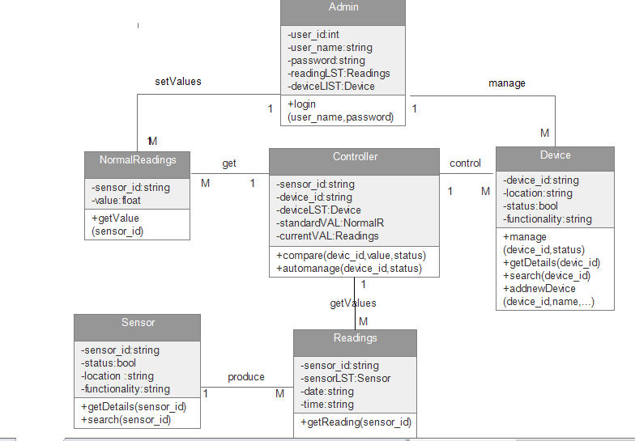

## Designs

### Desktop application

|  |
| --- |
|  |
|  |
|  |
|  |

### Mobile Application

|  |  |
| --- | --- |
|  |  |
|  |  |

### Web Application

|  |
| --- |
|  |
|  |
|  |

**Chapter 04**

# **. System Implementation**

## Introduction

This chapter is organized as Sections 1 presents an introduction about the proposed system followed by project Data Base in Section 2. Section 3 presents and explain desktop APP followed by web site in Section 4.Section 5 presents and explain mobile APP.

## Project codes:

For database scripts and project code this document has cd contains all project code.

## First section: desktop APP:-

First form for log in the system as shown in figure

This page is Log in, allow the system admin to login into system by using a user name and password as shown in figure.

|  |  |
| --- | --- |
|  |  |

This is the control form in which we can select any device and show its information as shown also can manual turn on /off it. When click on "" start program ''button and select one sensor, show the current readings on the textbox below.

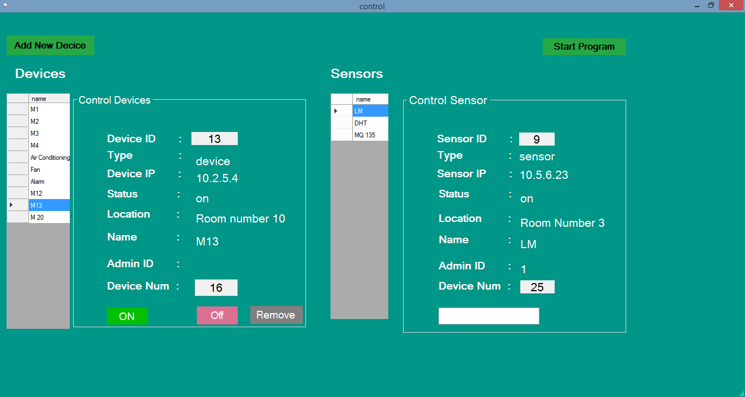

When click on "Add New Device" button, this form is shown to insert the required information and save it on the database with click on button "Add".

|  |
| --- |
|  |

## Second section: Website APP:-

It’s an important part in our project which enable handle devices remotely by using website …

This is the first page shown when open the website

|  |
| --- |
|  |

This is the main page of website in which we can control and manage all contents as shown.

|  |
| --- |
|  |

* Click on "change Account Setting " show the page:

|  |
| --- |
|  |

* Click on "Dashboard " show the page :

|  |
| --- |
|  |

This page show the reports of temperature, air quality and humidity as follow:

* When select "Temperature” show

|  |
| --- |
|  |

* When select "Daily Report " its show :

|  |
| --- |
|  |

This page show each up normal value of temperature and its time

* When select "Monthly Report " its show :

|  |
| --- |
|  |

It show the max of each day in the month and max value of this month

* Click on "Add New Device" show the page :

|  |
| --- |
|  |

To add new device, admin must insert all above information and click on "Add Device".

* Click on "Devices " show the page :

|  |
| --- |
|  |

This page show all devices and we can show device details, update its information or delete it from the system.

## Third section: Mobile APP:-

Its most look like the website…

|  |  |
| --- | --- |
|  |  |

This the first page, then show the login page, Admin must enter a correct user name and password then log in the APP.

This is the second page of APP in which we can control and manage all contents as shown.

|  |
| --- |
|  |

Admin can setting his account...

|  |
| --- |
|  |

This form declare the reports of each table of readings

|  |
| --- |
|  |

This form declare up normal reading of temperature in this day and calculate the max and min value of temp and show sensor information.

|  |
| --- |
|  |

This form show all devices .and we can show device details, update its information or delete it from the system. And add new device:

|  |  |
| --- | --- |
|  |  |

# References

|  |  |
| --- | --- |
| [1] | A. U. Sir: Thabt Alaa Muhamed Taha, "Environmental Newsletter: Number Sixty-six after hundred," [Online]. Available: http://www.aun.edu.eg/arabic/society/nov_2009.html. [Accessed 1 january 2017]. |
| [2] | [Online]. Available: https://www.arduino.cc. [Accessed 1 january 2017]. |
| [3] | M. Younan, S. Khattab, and R. Bahgat, "A WoT Testbed for Research and Course Project," in *Managing the Web of Things*, 2016, pp. 181-204. |
| [4] | [Online]. Available: https://www.pcmag.com/encyclopedia/term/41158/desktop-application. [Accessed 1 january 2017]. |
| [5] | "yourdictionary," [Online]. Available: http://www.yourdictionary.com/desktop-application. [Accessed 1 january 2017]. |